# **Transfer a Call in Skype**

When it comes to transferring a call, you have multiple options in Skype, you can a cold or warm transfer   
or even IM a contact before you transfer a call.

## **Cold Transfer (directly transfer the caller to another person or to Unified Messaging voicemail)**

1. Click the **Transfer** button.

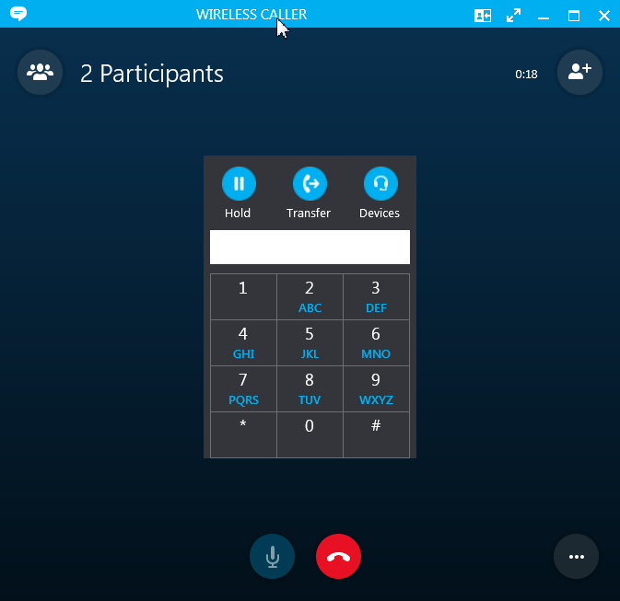

2. Search for contact, highlight the name, then click the **Transfer Now** button.   
(TIP: Make sure the contact is available first.)

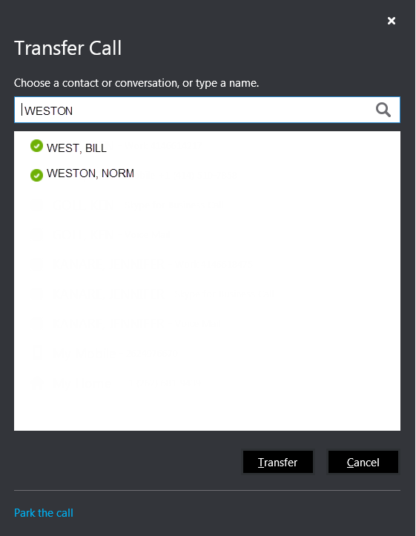

**Transfer a caller directly to Unified Messaging voicemail**  
(Skype-to-Skype users only)

Click on the contact’s picture, select the arrow next to the phone icon and choose **Voice Mail**.



## **Warm Transfer (caller on hold, speak to person you want to transfer caller to)**

Contact the person you’d like to transfer the call to. Instant Message the person or call them directly.

1. To call the contact, place first caller on hold. (Click **HOLD**.)

 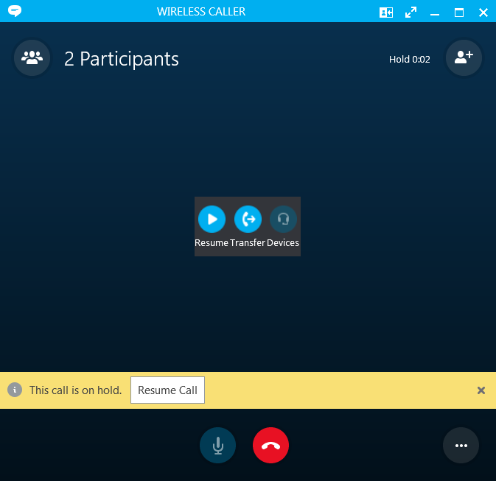

To take caller off Hold,   
click **Resume Call.**

1. Search for contact in Skype, then click the **phone icon** to dial that contact.



1. When ready to transfer the call, click the **More Options** icon.

Select “**Merge This Call Into**” to merge both callers into one call.

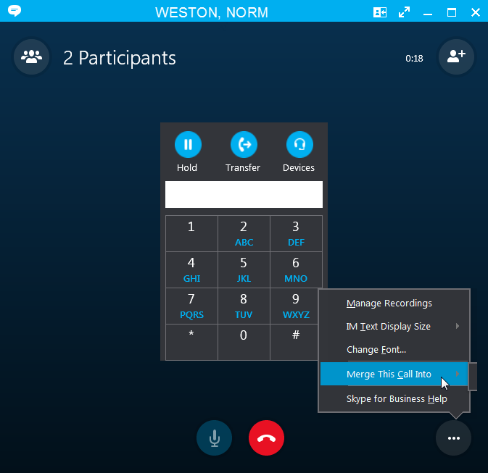

1. To disconnect yourself from the call, click the red **disconnect** button.

## **Warm Transfer (conference call with all callers)**

To keep all parties on the call so that everyone hears each other, you can conference in the third party.

1. From the conversation window, click the “Invite More” icon.



1. Search for the contact, then highlight the name and click **OK** to start the conference call.   
   (TIP: Make sure the contact is available first.)

